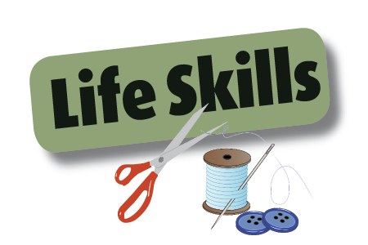**Name_______________________________________________**

**You have and will learn many “life skills” in Home & Career Skills class.**

**The term ‘Life Skills’ refers to the skills usually associated with managing and living a better quality of life. For example learning to prepare a meal can save you money, restaurants can be very expensive. Cooking also helps you eat healthier. Restaurants and prepared foods (like a frozen dinner) are usually high in fat & salt. If you cook a meal, you are in control of the fat & salt content.**

**In the sewing unit you have also learned “life skills”. Explain in a paragraph (*5 or more* complete sentence) *why sewing is a “life skill” & how it can help you and your family.* Give specific examples. You can continue on the back of you need more space.**

***Helpful hint.* If you’re “stuck”& don’t know what else to write, read your last sentence and ask yourself the question WHY? You should be able to build on your last sentence.**

______________________________________________________________________________________________________________________________________________________________________________________________________________________________________________________________________________________________________________________________________________________________________________________________________________________________________________________________________________________________________________________________________________________________________________________________________________________________________________________________________________________________________________________________________________________________________________________________________________________________________________________________________________________________________________________________________________________________________________________________________________________________________________________________________________________________________________________________________________________________________________________________________________________________________________________________________________________________________________________________________________________________________________________________________________________________________________________________________________________________________________________________________________________________________________________________________________________________________________________________________________________________________________________________________________________________________________________________________________________________________________________________________________________________________________________________________________________________________________________________________________________________________________________________________________________________________________________________________________________________________________________________________________________________________________________________________________________________________________________________________________________________________________________________________________________________________________________________________________________________________________________________________________________________________________________________________________________________________________________________________________________________